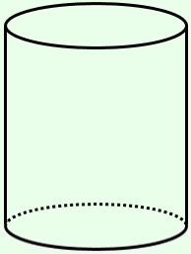

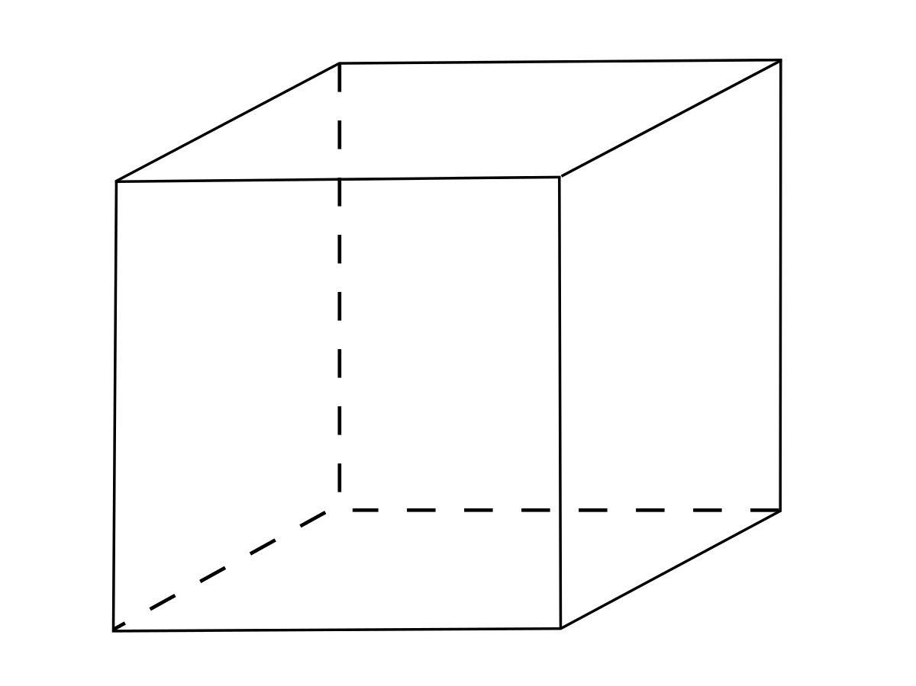

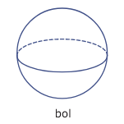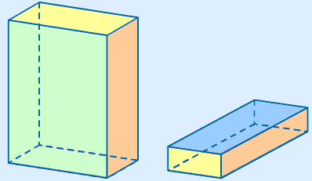

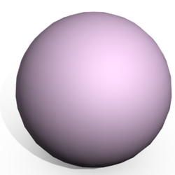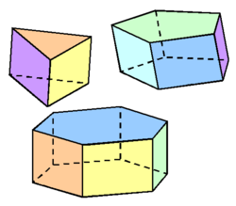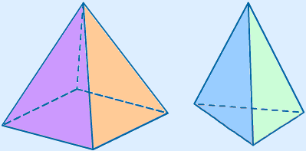



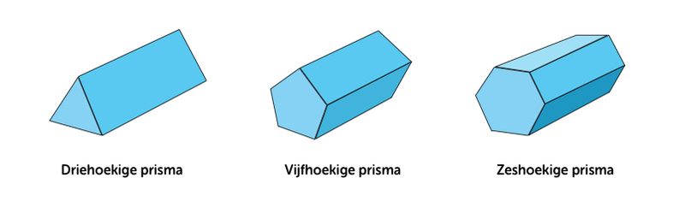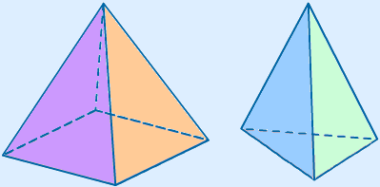

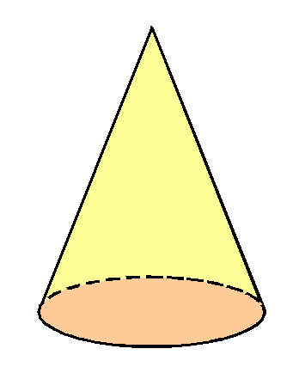

|  |
| --- |
| **cilinder** |

|  |
| --- |
| **kegel** |

|  |
| --- |
| **kubus** |

|  |
| --- |
| **piramide** |

|  |
| --- |
| **balk** |

|  |
| --- |
| **bol** |

|  |
| --- |
| **prisma** |

|  |
| --- |
| grondvlak |

|  |
| --- |
| ribbe |

|  |
| --- |
| zijvlak |